11/2/2013

**State-MEANT**

**Software Design Document**

**Team Members:**

TODD MACEDO

Tharsika paramjothy

jay ravel

suhail KHAN

monil Wani

Table of Contents

1. Introduction 3

1.1 Purpose of this document 3

1.2 Project Scope 3

1.3 1.3 Overview 3

2. Use cases 3

2.1 Use case: Admin 3

2.2 Use case: Student 5

2.3 Use case: Teacher 5

3. Sequential diagrams 7

3.1 Sequence diagram: Admin 7

3.2 Sequence diagram: Teacher 8

3.3 Sequence diagram: Student 9

INTRODUCTION  2

1.1  Purpose  2

1.2  Scope  2

1.3  Overview  2

1.4  Reference Material  2

1.5  Definitions and Acronyms  2

2.  SYSTEM OVERVIEW  2

3.  SYSTEM ARCHITECTURE  2

3.1  Architectural Design  2

3.2  Decomposition Description  3

3.3  Design Rationale  3

4.  DATA DESIGN  3

4.1  Data Description  3

4.2  Data Dictionary  3

5.  COMPONENT DESIGN  3

6.  HUMAN INTERFACE DESIGN  4

6.1  Overview of User Interface  4

6.2  Screen Images  4

6.3  Screen Objects and Actions  4

7.  REQUIREMENTS MATRIX  4

8.  APPENDICES  4Software

# Introduction

## Purpose of this document

The purpose of this document is to specify each requirement of the system in detail. It helps the client to get the better understanding. The intended audience for this document is Dr. Lidia Morrison.

## Project Scope

The requirements elicitation team includes each member of Team for the States Map Game: Todd Macedo, Tharsika Paramjothy, Jay Raval, Suhail Khan and Monil Waniand. These team members shall complete this project by writing project specifications, designing and testing the system, completing user documentation, and migrating the final system over to the client. The system shall include the Grade-5 students. Other prospective users shall be class teachers and parents. This game is very useful for the students to develop their history knowledge.

## 1.3 Overview

The result of the requirement elicitation shall be an educational history based game. This game is mainly focused on Grade -5 student’s history subject. This system shall be successful after the following specifications are fulfilled.

# System Overview

# System Architecture

# Data Design

## Use case: Admin

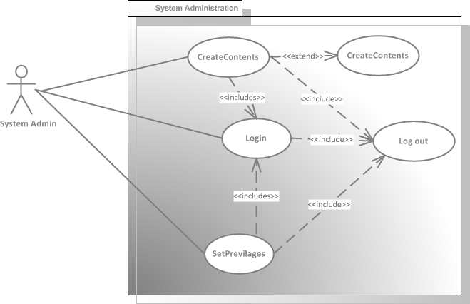

|  |  |
| --- | --- |
| **Use Case #:** | U001 |
| **Scenario Objective:** | Identify program response to several user actions |
| **Priority:** | High |
| **Source:** | Suhail Khan |
| **Actor:** | System Administrator |
| **Flow of events:** | |
| **1 Basic flow** | |
|  | User launches the application and supply user id and password and click on “Login” button |
|  | User log on successfully and the home/menu page will be displayed. |
|  | User selects the “Create Contents” menu and content management screen will be displayed |
|  | User selects the state and enter question and set the answer options |
|  | User clicks on “Save button” to save the contents |
| **2 Alternate flow** | |
|  | At any step user can cancel the operation   * Cancel operation will display home page to user and will not save any data in the system. |
| **3 Includes** | |
|  | Exception occurs |
| **4: Precondition** | |
|  | User logged in |
| **4: Post condition** | |
|  | All the transactions save in the system successfully. |
|  | User loges out of the system or system timeout user’s session after 15 min. |

Note: Issues none.

## Use case: Student

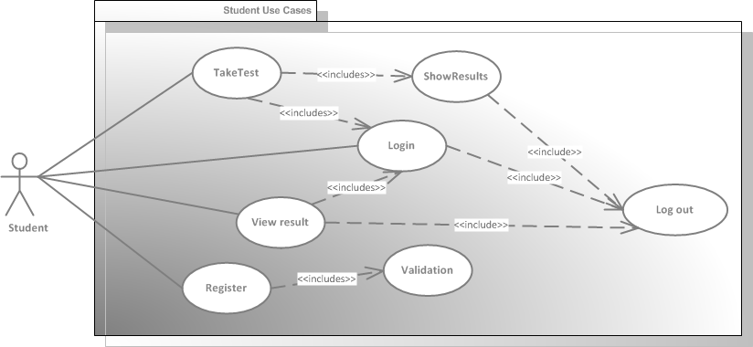

## Use case: Teacher

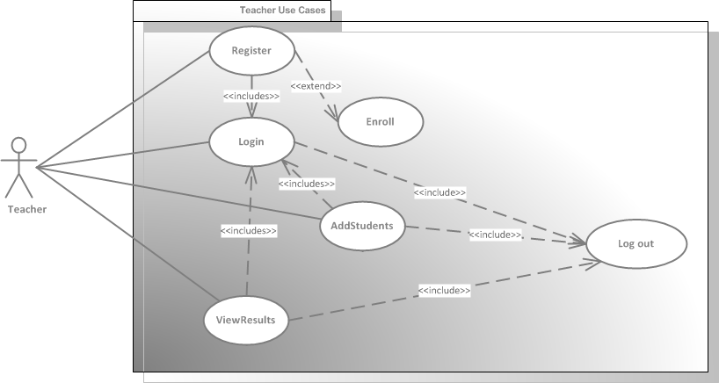

# Component Design

## Sequence diagram: Admin



## Sequence diagram: Teacher



## Sequence diagram: Student

